Version：1360315 BDL7030QD

**XXXXXXXXX**

# 70-inch Large Size Commercial Display

**Model: BDL7030QD**

**Revision History**

|  |  |  |  |  |  |  |
| --- | --- | --- | --- | --- | --- | --- |
| **Part number** | **Version** | **Publish date** | **Written by** | **Auditing** | **Approval** | **Remarks** |
| 1360315 | BDL7030QD-GGS20180327 | 2018\03\27 |  |  |  |  |
|  |  |  |  |  |  |  |

**Note**：All right reserved by XXXXXXXX.Please contact with us for the latest updates.

## Product Specifications

|  |  |
| --- | --- |
| **Display** | |
| Panel | 70 inches LED backlight |
| Active Area(mm) | 1549.44 (H) ×871.56 (V) |
| Aspect Ratio | 16:9 |
| Resolution | 1920×1080 |
| Brightness | 400cd/m2 |
| Contrast Ratio | 4000:1 |
| Viewing Angle | ( R/L 89 (Min.), U/D 89 (Min.)) |
| Display Colors | 16.7 Million colors (10-bit) |
| Color temperature | 1000K |
| Life Expectancy | 30000 hours |
| Response time | 8ms |
| **System configuration** | |
| Operating system | Android 5.1 |
| CPU | ARM Cortex A17(4 core) 1.8GHz |
| GPU | ARM Mail-764(4 core) |
| Memory | 2G DDR3 |
| Storage | 8G eMMc / NAND FLASH |
| **Touch** | |
| Model | / |
| Touch point | / |
| Touch type | / |
| Touch precision | / |
| Touch resolution | / |
| Response time | / |
| Input mode | / |
| Smallest touch objects | Single: /  Multipoint: / |
| **External ports** | |  |
| Signal ports | VGA×1, HDMI×1, VGA Audio In×1, Audio Out×1 |
| Network ports | LAN×1(10/100M Ethernet), WIFI(802.11bgn), 3G/4G |
| Storage extension | Micro SD Card(TF) ×1, 32GB (Max) |
| Other ports | USB2.0×2, SIM Card×1, AC Switch×1, IR IN×1 |
| **Multimedia** | |
| media file formats | Video：MPEG1、MPEG2、MPEG4、H.264、WMV、MKV、TS、flv and other mainstream video formats |
| audio: MP3 and other audio formats. |
| picture: JPG、JPEG、BMP、PNG、GIF |
| text：txt |
| Others：/ |
| Play mode | Horizontal screen, Vertical screen, Full screen, Split screen |
| Program transmission mode | USB, LAN, WAN |
| **Machine parameters** | |
| Product size (mm) | 1611.6 (H)×933.6 (V)×97.7(D) |
| Carton size（mm） | 1813 (H)×1143 (V)×340 (D) |
| VESA (mm) | 600*500 |
| Screen suspension mode | Landscape |
| Menu language | Chinese, English |
| Machine color | black |
| Weight | net：53KG gross：65.5KG |
| Power consumption | 320W (MAX) |
| Speaker | Stereo 2×2W 4Ω |
| Smart volume | Time sharing volume |
| Watchdog function | Yes |
| Timing | Multi-period timing switch, Automatic timing switch |
| Management software | C/S framework ADPE/Ezposter, B/S framework GTV System |
| Power supply | AC~100-240V (50/60Hz) |
| Working environment | 0〜40℃ 10% 〜 85%RH No condensation |
| Storage environment | -10〜60℃ 10% 〜 90%RH No condensation |
| Accessories | 1. Remote control x1 2. AC power cable x1(standard) 3. AAA battery x2 4. Safety and environmental protection precautions x1 5. Certificate x1 |
| Certificates | CCC/CECP |

## Schematic Drawing

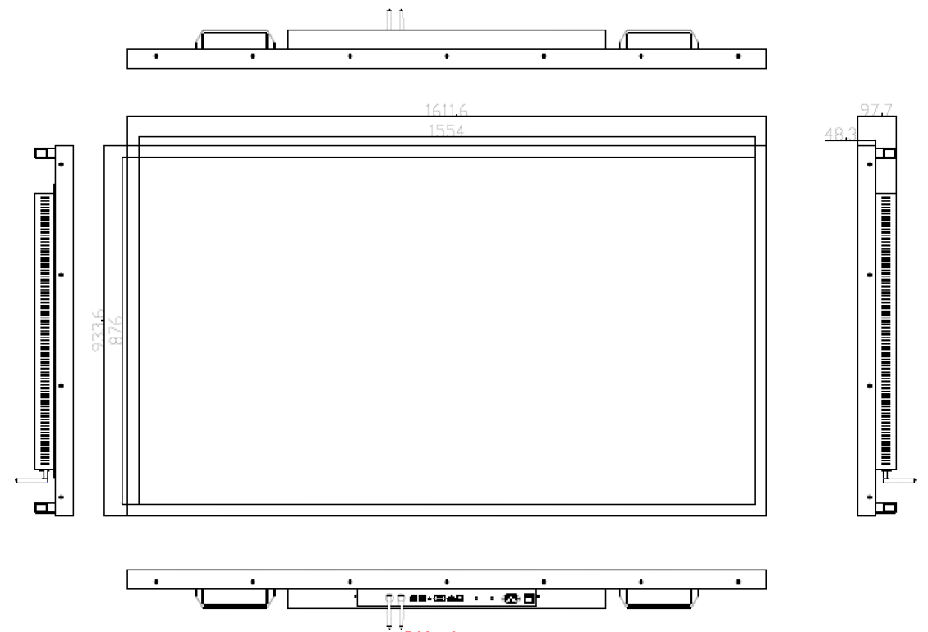

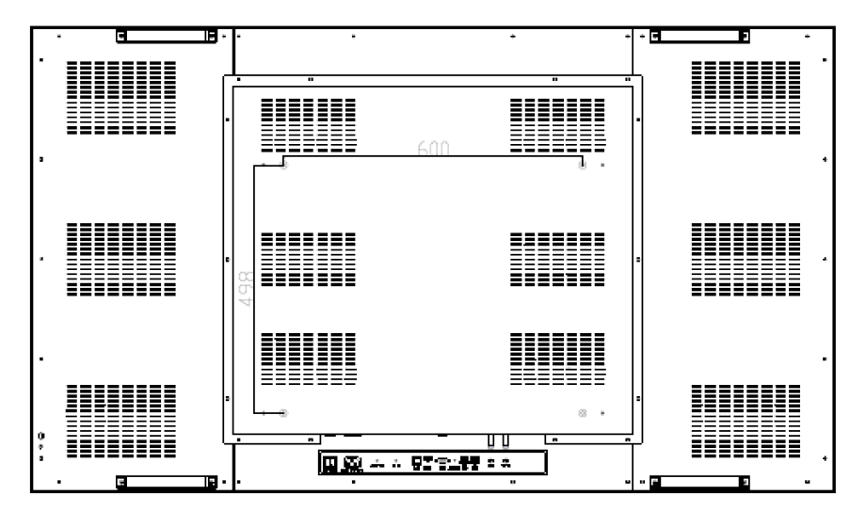

## Product Images

## 

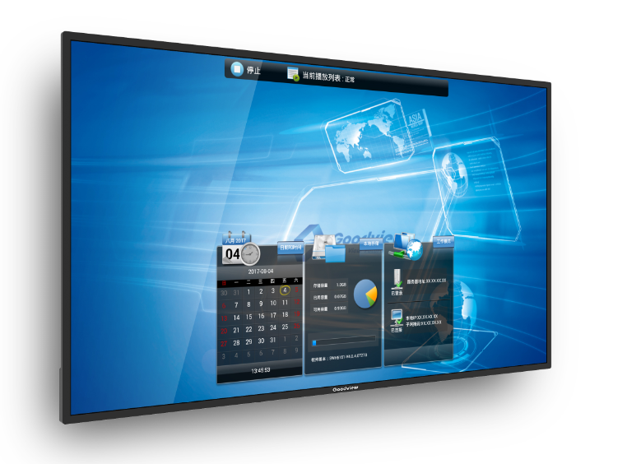

## Packaging

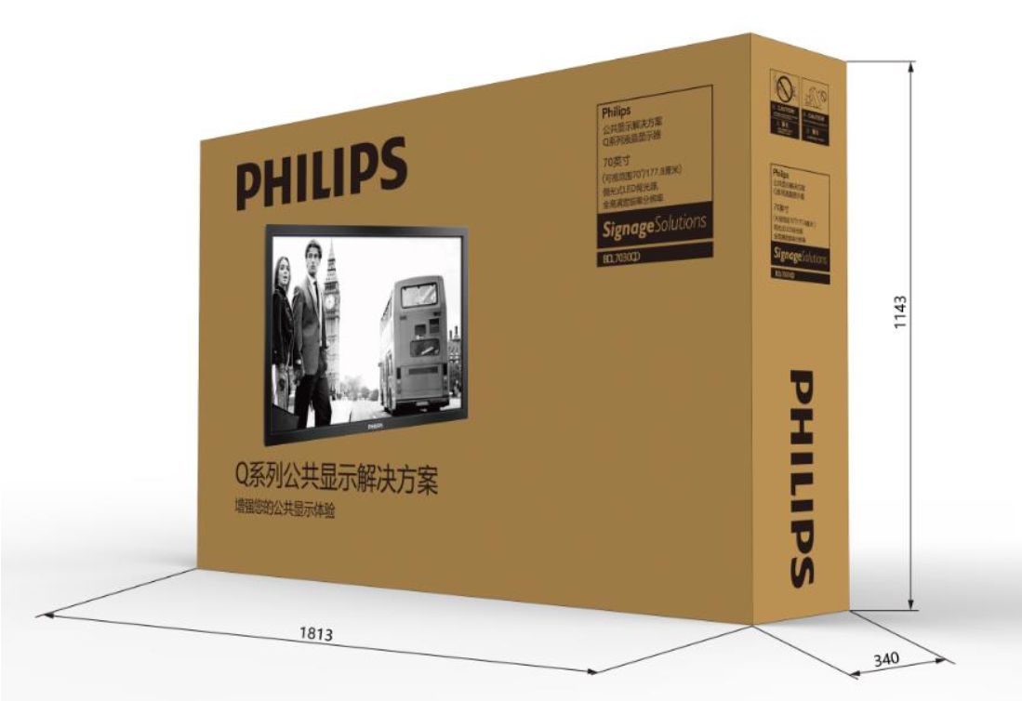

**Note**：All right reserved by XXXXXXXX.Please contact with us for the latest updates.